Smart Wireless Ag Sensors for Measurement of Soil Water Contents
  - Project plan
Team Number: 38
Client: Iowa State University – Research Department
Adviser: Dr. Liang Dong
Team Members/Roles:
Colin Cox – Project Manager – Software Team
Jarrod Droll – Lead Software Testing – Sensor Team
Rachel Hoke – Meeting Organizer – Sensor Team
Wage Miller – Chief Hardware Engineer – Control Box Team
Scott Rowekamp – Chief Software Engineer – Software Team
Tyler Thumma – Lead Hardware Testing – Control Box Team
Team Email: sdmay18-38@iastate.edu
Team Website: http://sdmay18-38.sd.ece.iastate.edu/
Revised: 10-29-17 / v2
Table of Contents
List of Figures iv
List of Tables iv
List of Symbols iv
List of Definitions iv
1 Introductory Material 1
1.1 Acknowledgement 1
1.2 problem Statement (2 paragraphs+) 1
1.3 Operating Enviroment (one paragraph +) 1
1.4 Intended Users and Intended uses (two paragraph +) 1
1.5 Assumptions and Limitations 1
1.6 Expected End Product and other Deviverables 2
2 Proposed Approach and Statement of Work 3
2.1 Functional requirements 3
2.2 Constraints considerations 3
2.3 Technology considerations 3
2.4 Safety considerations 3
2.5 Previous Work and Literature 3
2.6 Possible Risks and risk management 4
2.7 Project Proposed Milestones and evaluation criteria 4
2.8 Project tracking procedures 4
2.9 Objective of the task 4
2.10 Task approach 4
2.11 Expected Results and Validation 4
3 Estimated Resources and Project Timeline 5
3.1 Personnel effort requirements 5
3.2 other resource requirements 5
3.2 Financial requirements 5
3.3 Project Timeline 5
4 Closure Materials 6
4.1 conclusion 6
4.2 References 6
4.2 Appendices 6

Include these sections only as needed.
List of Figures

List of Tables

List of Symbols

List of Definitions

1 Introductory Material

1.1 Acknowledgement
We would like to thank the following groups/people for their help throughout this project.
- Iowa State University Research Departments
  - Electrical Engineering
  - Agronomy
- Leland Harker
- Dr. Liang Dong, Dr. Azahar Ali and students (Grad and PhD.)
  - Xinran Wang
  - Yuncong Chen

1.2 problem Statement
As the population of the world increases we need to account for feeding everyone. The problem that the research department is facing is how to improve crop yields within agriculture by looking at the differences between genetics of plants and the chemical levels within plants and soil effected by fertilization. To get this information the electrical and agriculture research departments have teamed together and developed plant and soil sensors to collect data for analysis.
Our team is working to improve these sensors, to allow for enhanced data collection and interpretation. We are designing and developing new sensors to be used out in the fields, while creating an updated user interface to access and store data in. There are several changes for improving the current design of the sensors, and they are categorized as follows:
- Improving the control box. Looking at the components and housing.
- Develop more sensors for communication testing we currently only have one prototype of each plant and soil sensor.
- Advancing the application used for collecting data. A commercial app is currently being used for data analysis, and only one sensor can be analyzed at a time.
These three main general change areas to our project can be broken into corresponding solutions for each problem.
- For the control box, we would like to decrease the size down to ¼ of what it is currently. This will improve efficiency and reducing power consumption.
- Creating more prototypes is our solution to the second problem listed above, and our plan is to manufacture 10 sensors and have them all communicating with the application out in the fields.
- Lastly, our group plans on making our own application that can allow for data extraction and analysis of all the soil and plant sensors simultaneously. Improving the user interface and adding useful functions like a data plot to show trends throughout the season.
In making these improvements the team can find out what would be the best type of crops to plant in different environments and how much fertilizer will be needed throughout the season. Ultimately this research can be used to help farmers grow better crops increasing their yields allowing for more food and less waste.

1.3 Operating Environment
Our plant and soil sensors will have an operating environment of either a corn or soybean field. With that in mind, they need to be waterproof in order to withstand rain, be able to withstand relatively extreme temperature swings depending on farming location, and be resistant to insects or animals within the fields. Additionally, the sensors will be out in the field for anywhere from a few days to a few weeks or months, so sustainability is a key component that we intend to address with a rechargeable battery and solar panels.

1.4 Intended Users and Intended uses
The intended users for our sensors in the near future are those researching crop yields. This will begin with researchers in the College of Agriculture at Iowa State University and eventually be outsourced to other agricultural companies.
The plan is to then have our product used by farmers in order to give them the technology necessary to conduct soil sample testing on their own, rather than having to ship soil out for testing to a third-party company.
We need to make sure that our sensors meet the standards of both intended users, we plan on achieving this by upkeeping and improving the accuracy of the sensors and data collection while improving the durability and longevity of the control boxes. Also we are allowing for easy instillation into the fields.

1.5 Assumptions and Limitations
Assumptions:
- Design sensors specifically for research purposes
- Each control box will have one sensor. These sensors will be interchangeable in order to test plants and soil.
- Design a network consisting of at least 10 sensors.
Limitations:
- The end product needs to be ¼ of original size
- The system must operate under moderate temperature changes (-20 Fahrenheit to 120 Fahrenheit)
- Project budget cannot exceed $2,000
- Battery life must be up two weeks minimum

1.6 Expected End Product and other Deliverables
Soil and Plant Sensors
Two new sensor designs that incorporate a circular design that will make the fabrication process more efficient.
User Interface
User interface that can be accessed from a mobile device for easy transfer and view of data on sensors.
Mesh Network Capabilities
The software and hardware of the sensor box must support a mesh style network so that multiple sensors can connect to a collection point without additional infrastructure.
Control Box
The size of the control box is to be reduced to a quarter of its current size. In doing so the electronic components also have to be reduced in order to fit in the new control box. Smaller circuit boards, and battery for each box.

2 Proposed Approach and Statement of Work

2.1 Functional requirements
Functional Requirements:
- Sensor box ¼ of original size
- Battery life up to two weeks
- Can withstand temperatures ranging from –20 Fahrenheit to 120 Fahrenheit
- Portable
- Takes accurate measurements of phosphate/nitrogen/potassium concentration
- Waterproof and insect resistant

2.2 Constraints considerations
Nonfunctional requirements:
- Easy to navigate software interface
- Efficient networking
- Cheap for consumers
- Not harmful to environment (little to no emissions)
Our project will follow standard protocols developed by IEEE, the Code of Ethics. These protocols are applicable to our project as we are working in a team as well as with a client and potentially the public. All decisions will be made ethically and morally in order to ensure proper conduct.

2.3 Technology considerations
We plan to design the PCB for the sensors to be more circular in shape. Our intuition tells us that this should be a suitable solution to our current sensors problems. The strengths to our proposed solution are the removal of the "step up" problem and the easier deposition of silver on our PCB.

2.4 Safety considerations
Our group has received training on using the PCB mill and soldering as to avoid any injuries that could occur. We will also have the safety of the public in mind when it comes to our end product as farmers and researchers will be using the devices regularly.

2.5 Previous Work and Literature
Currently these sensors are the first of their kind so all previous work is transferred to us through conversations with Dr. Liang Dong and his graduate students.

2.6 Possible Risks and risk management
Some possible setbacks currently would be: lack of resources for previously designed circuit, and the sensor re-design process.

2.7 Project Proposed Milestones and evaluation criteria
Our group is split into three groups: sensors, control box, and application. The proposed milestones are listed below:
Sensors:
- Fabricate a working soil sensor. - To test this, we will continually check the conductivity of the sensor throughout the fabrication process.
- Test sensor in soil water with old control box. - To test this, we will use an old sensor and control box on the same soil water as the new sensor and control box and compare the results.
Control Box:
- Reduce the size of the control box PCB. - Test the new PCB design against the old design and compare the results.
- Reduce the size of other components in control box. - Assemble the components of the new control box and test it alongside the old control box and compare the results.
- Print a new box for the new control box components.
Application:
- Create software for application, improving data collection and user interface.
- Test communication of sensors with application.
- Test for mass quantities of data collection and communication between 10 sensors.

2.8 Project tracking procedures
Our group will be tracking progress via our timeline as well as using websites such as GitLab and CyBox. We will also be meeting with our client biweekly and corresponding graduate students on a need-to-meet basis.

2.9 Objective of the task
Our teams task is to improve the sensors within the following aspects:
- Fabrication of the sensors
- Efficiency and size of the control box
- Updated application with data collection
- Communication between sensors and app (advance software)

2.10 Task approach
We split our team into three groups: sensors, control box and application development.

2.11 Expected Results and Validation

3 Estimated Resources and Project Timeline

3.1 Personnel effort requirements

Name | Task | Explanation
Colin Cox | Software / Application
Jarrod Droll | Sensors
Rachel Hoke | Sensors
Wage Miller | Control Box
Scott Rowekamp | Software / Application
Tyler Thumma | Control Box

3.2 other resource requirements
The resources required for this project include:
- Circuit design components (Resistors, capacitors, op-amps, etc.).
- Circuit design software (Multisim, Ultiboard).
- Chemical solutions necessary for sensor development.

3.2 Financial requirements
According to our client our project has a budget of $2,000 to work with.

3.3 Project Timeline
Semester 1:
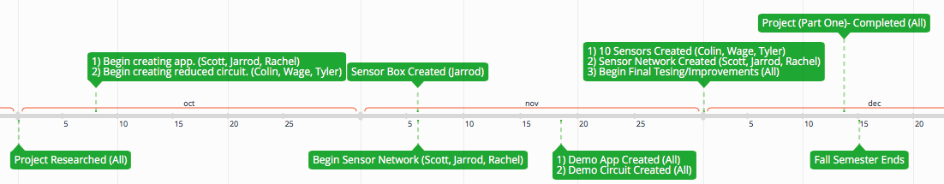
Semester 2:
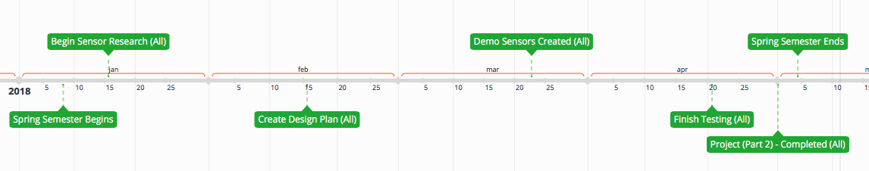
Throughout the year we will be focusing on different aspects of the project. We have dedicated our first semester towards learning, designing, and testing the sensors. Once we have completed and finalized our new design plan we will begin work on implementing it within the second semester building multiple sensors and testing them in the field.

4 Closure Materials

4.1 conclusion
Our team is focused on improving the sensors in order to increase their abundance in crop yield research, by doing so researchers will be able to develop higher quality seeds and knowledge on effects of fertilizer. We plan on accomplishing many of our goals for advancing and improving our system, while grow stronger as a team to ensure our clients a successful product. We will accomplish this through research and collaboration with our team and advisors throughout the project timeline.

4.2 References

4.2 Appendices

